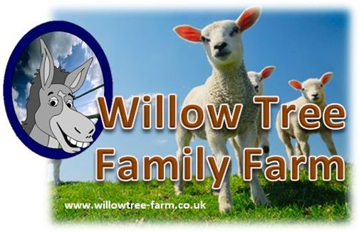
Care group Booking Form
PLEASE NOTE if you are paying cash on the day there is no need to book with us

PLEASE CHECK AVAILIBILITY BEFORE SENDING THE FORM TO AVOID DISSAPOINTMENT.
Please complete this booking form and email to david.anthony@willowtree-farm.co.uk.
Please note we cannot take provisional bookings.
YOUR BOOKING WILL BE SECURED ONCE WE RECEIVE THE BOOKING FORM. Once received, a full invoice will be sent for the numbers stated on the form. Cancellations or amendments within 28 days of your visit will be charged in full.
ALL PAYMENTS MUST BE PAID FOR IN FULL PRIOR TO YOUR VISIT.
WE RESERVE THE RIGHT TO REFUSE ADMISSION IF PAYMENT IS NOT RECEIVED BY ARRIVAL.
If you are paying by cheque or BACS this needs to have CLEARED 5 working days before your visit.
Annual Passes and Corporate cannot be used in conjunction with our school packages.

Date of visit
Name of Organizer
Name of Group
Address
 |  | Postcode
Office Email Address |  | Contact No
Invoice Email Address
No. of careers |  | Arrival Time
No. of Adults |  | Departure Time

Food options | £10.00 per platter  Please say how many these are for 9 people  Please choose filling option
 | Ham |  | Egg
 | Cheese |  | Mix platter

How did you hear about us?
Lunch:
Drinks and snacks are also available to purchase from the Café.
The Café is able to cater for all requirements however we will need prior notice.
Please return this form to: Email: david.anthony@willowtree-farm.co.uk Telephone: 01623-748808 / 07798895093

Website: www.willowtree-farm.co.uk

Signature______________________________________

